Erick Cabrera

A20321505

ITM 312

Lab 02

**Program 1 Source Code:**

/*

* File: main.cpp

* Author: Erick Cabrera

*

* Created on February 6, 2017, 12:08 PM

*/

#include <cstdlib>

#include <iostream>

#include <string>

using namespace std;

/*

*

*/

int main(int argc, char** argv) {

cout << "Please follow the steps to successfully troubleshoot your engine." << endl;

string statusLight;

int meter;

string pressure;

string flow;

cout << "What color is the status light?" << endl;

cin >> statusLight;

if (statusLight == "green"){

cout << "restart the engine";

return 0;

} else if(statusLight == "red"){

cout << "Shut off input lines" << endl;

} else if(statusLight == "amber"){

cout << "Check fuel service routine" << endl;

return 0;

}

cout << "What does meter #3 read?" << endl;

cin >> meter;

if(meter < 50){

cout << "Check main line for test pressure. What does it read?" << endl;

cin >> pressure;

if(pressure == "normal"){

cout << "Refer to motor service manual" << endl;

return 0;

} else if(pressure == "high" || pressure == "low"){

cout << "Check main line service manual" << endl;

return 0;

}

}else if(meter >= 50){

cout << "Measure flow velocity at inlet 2-B. \nWhat does it read?" << endl;

cin >> flow;

if(flow == "normal"){

cout << "Refer to inlet service manual" << endl;

return 0;

} else if(flow == "high" || flow == "low"){

cout << "Refer unit for factory service" << endl;

return 0;

}

}

return 0;

}

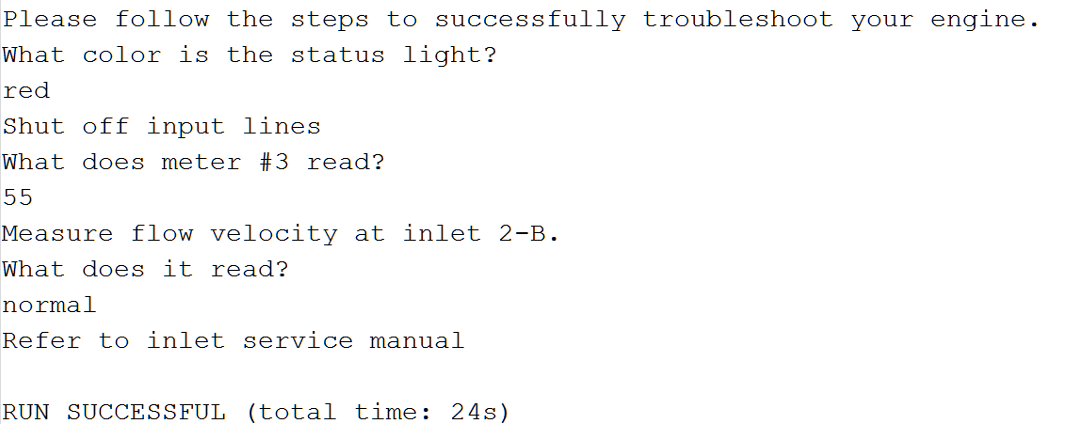**Output:**

**Program 2 Source Code:**

/*

* File: main.cpp

* Author: Erick Cabrera

*

* Created on February 6, 2017, 12:08 PM

*/

#include <cstdlib>

#include <iostream>

#include <string>

#include <time.h>

using namespace std;

/*

*

*/

int main(int argc, char** argv) {

srand(time(NULL));

cout << "Please follow the steps to successfully troubleshoot your engine." << endl;

int statusLight;

int meter;

int pressure;

int flow;

cout << "What color is the status light? (1 for Green, 2 for Red, 3 for Amber)" << endl;

statusLight = rand() % 3 + 1;

if (statusLight == 1){

cout << "restart the engine";

return 0;

} else if(statusLight == 2){

cout << "Shut off input lines" << endl;

} else if(statusLight == 3){

cout << "Check fuel service routine" << endl;

return 0;

}

cout << "What does meter #3 read?" << endl;

meter = rand() % 50 + 1;

if(meter < 50){

cout << "Check main line for test pressure. What does it read? (1 for Normal, 2 for High, 3 for Low)" << endl;

cin >> pressure;

if(pressure == 1){

cout << "Refer to motor service manual" << endl;

return 0;

} else if(pressure == 2 || pressure == 3){

cout << "Check main line service manual" << endl;

return 0;

}

}else if(meter >= 50){

cout << "Measure flow velocity at inlet 2-B. \nWhat does it read? (1 for Normal, 2 for High, 3 for Low)" << endl;

flow = rand() % 3 + 1;

if(flow = 1){

cout << "Refer to inlet service manual" << endl;

return 0;

} else if(flow == 2 || flow == 3){

cout << "Refer unit for factory service" << endl;

return 0;

}

}

return 0;

}

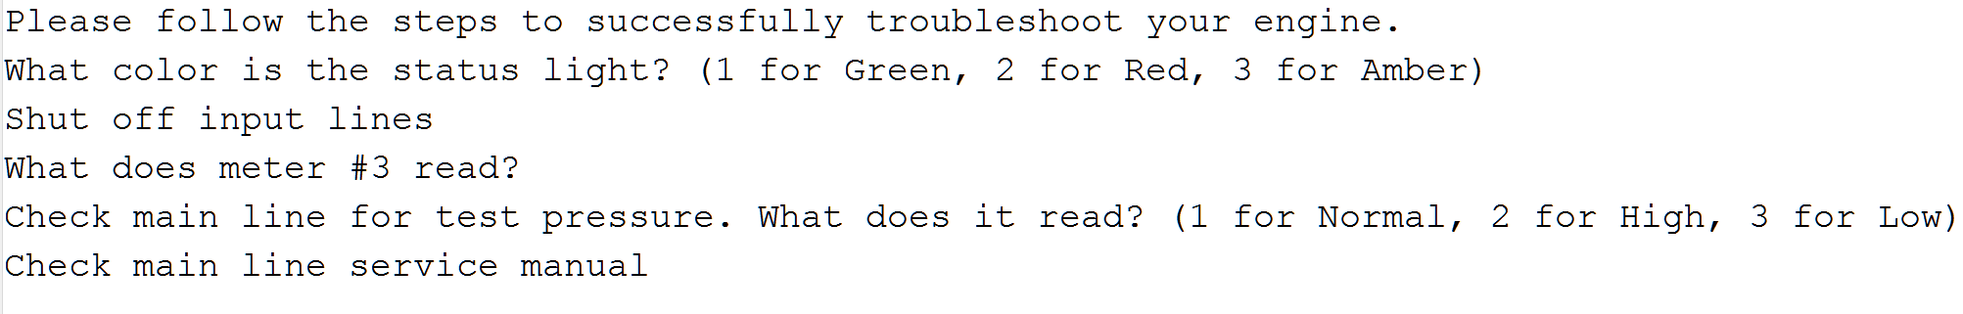**Output:**